Shanghai Wafer Microelectronics Co., Ltd.
23E,Liang Feng Building,NO.8,DongFang Road,Shanghai,China Tel.: (0086) 21 6845-8945 Fax: (0086)21 5045-4820

MDB Coin Changer and MDB Bill Acceptor to RS232 Interface
Model: MDB-RS232 (New Version box type V3)

SPECIFICATIONS
Communication format:
Baud rate: 9600 Start bit: 1 Data bits: 8 Parity: NO Stop bit: 1
PC data Send: Hex PC data Receive: ASCII Hardware Specification.
Power Min 20 VDC ( Normal working voltage 24...30 AC or DC )
Consumes an idle current < 0.05A (No MDB payment device connected) Cable MDB connector, Standard RS232 serial cable and DC2.1 Power connector Dimensions approx. 100 x 42 mm (Not include the cables)
Weight approx. 100 g

Install the MDB-RS232
( VMC can be Computer(PC) or PLC or Android main board )
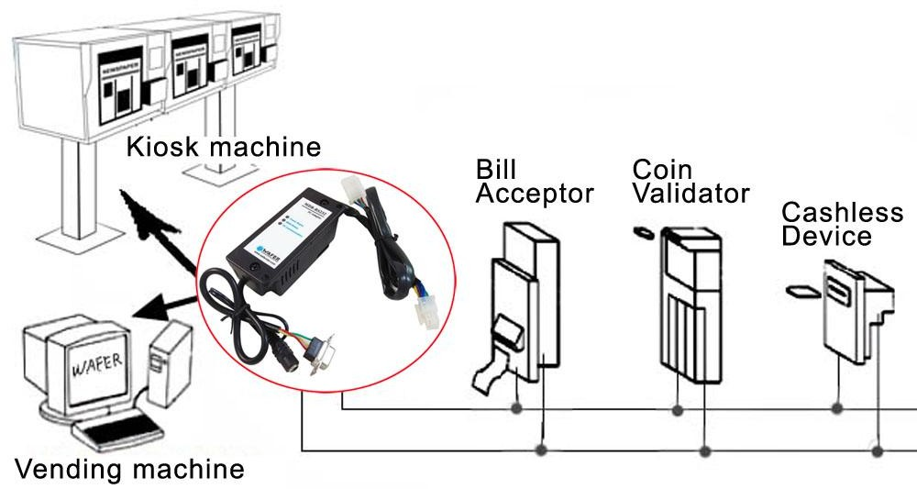

Below is the picture of two types of MDB-RS232, the same function and protocol ,the only difference is Three LED version will enable the payment device from the start and Five LED version start with disable status for payment device and user need to use the enable command to enable.
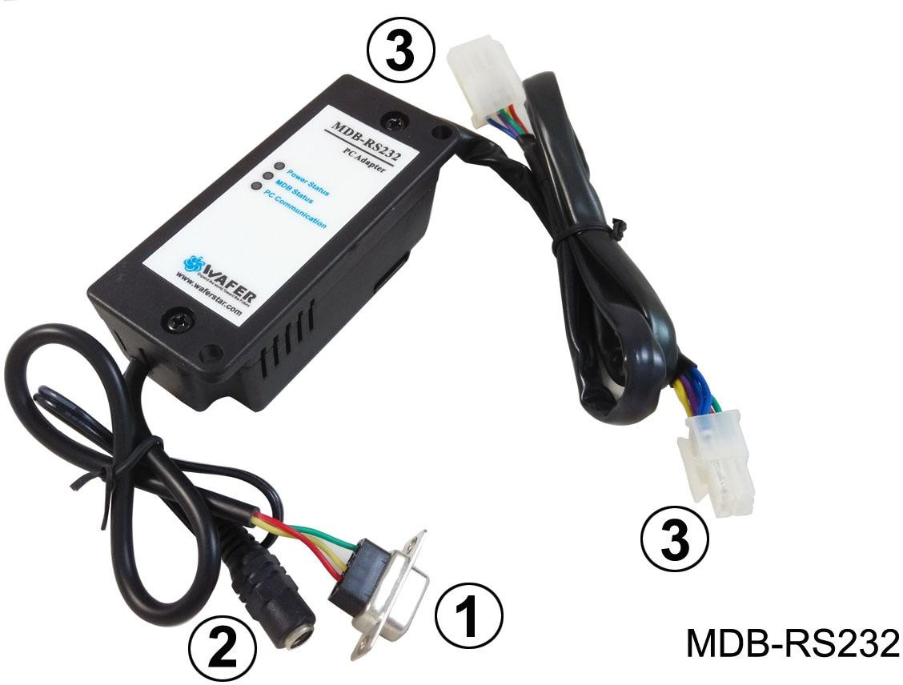
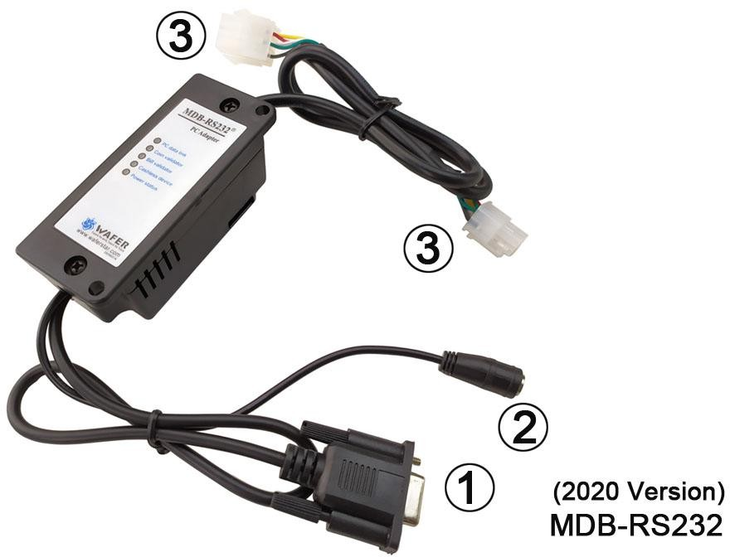

- (1) RS232 connector to Computer COM port
- (2) Power connector for AC/DC power supply (Normally we use the DC24V)
- (3) MDB connector to bill acceptor,coin validator or card reader

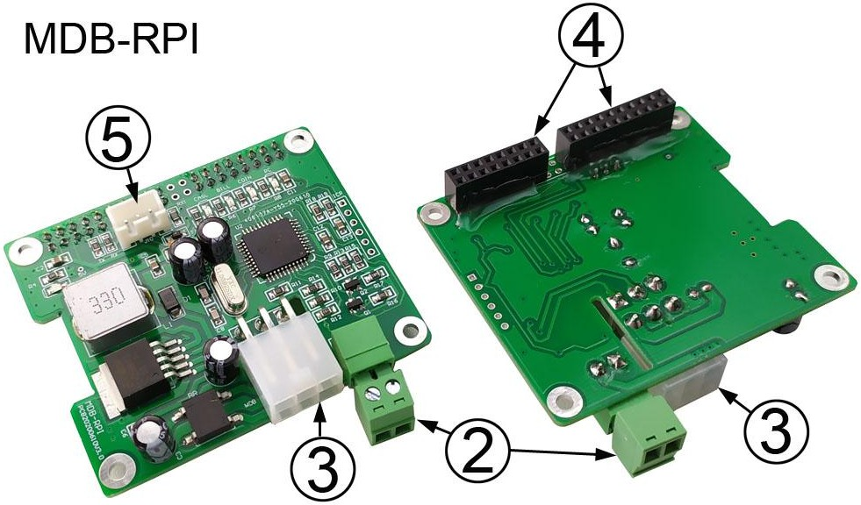
- (2) Power connector for AC/DC power supply (Normally we use the DC24V)
- (3) MDB connector to bill acceptor,coin validator or card reader
- (4) GPIO to Raspberry Pi board (Use RXD, TXD, GND and Ouput 5V to Raspberry pi)
- (5) Serial port to PC (Can use this port to test with PC software)
Installation is relatively simple; there are only three connections that must be made for full functioning of the device. There are connectors on the MDB adapter box.:
One cable plugs into a 24VDC power supply. (When connecting the DC24V power supply, there is no need to consider the specific polarity. The 6-pin Molex connects to the MDB devices. The final connector is a DB-9 and connects into the back of the computer or any other main board with RS232 port. There should be an open port on the back of the computer labeled “SERIAL2” or “COM2.” If you only has the USB port on your computer,then would be easy for you to order a RS232/USB adapter.
For MDB-RPI board,has two serial port to PC and also to Raspberry pi board GPIO.Also it will supply the DC5V voltage for Raspberry pi board.
After connected the device,and then Apply power on with DC24V. Check for “Power Status”
LED on the box (RED led) indicating power is OK.
If the MDB device is properly connected and working properly,then the “MDB Status” LED should start to flash.
On the MDB-RS232 box also has another “PC Communication” LED,that would be flashing if has any data sendt from MDB-RS232 box to PC.

Software
The MDB-RS232 sends information generated by the MDB device directly to the PC via RS-232 serial communication. There is no need to poll each MDB device. This is done by the MDB-RS232. By default the MDB-RS232 will poll all known MDB devices. The MDB-RS232 then sends data to the PC if there is activity. The information sent to the PC is send as bytes in hexadecimal. For activity data,the first byte sent is the device ID. For example 30 XX means that a bill validator has sent information. Whereas 08 XX means that a coin mechanism has sent data. Consult the MDB V4.2 command specification for commands specific to your MDB device.

How to use the command to communicate with the MDB-RS232 adapter box?
Data sent and reply are all compabitle with the MDB protocol.
PC command: Just use the same command as the MDB protocol for VMC
PC received data1: Any data sent back according to PC query instructions, that is the same format as the MDB protocol,no need to add the first device ID byte
PC received data2: Any activity data from payment device will be sent to PC automatically and the first byte is the device ID
For example, Coin acceptor setup command: 09
After sent the data 09 from PC , then adapter box will read and send back the coin acceptor setup information: 03 11 56 05 01 00 03 01 02 00 00 00 00 00 00 00 00 00 00 00 00 00 00 76
For example, Bill acceptor enable command: 0C FF FF FF FF
After sent the data 0CFFFFFFFF from PC , then adapter box will send to bill acceptor and send back the validator response Data: 00
Above PC received data,don’t have the device ID at the first byte,but following data will have Activity data from coin acceptor,For example a coin is accepted will be sent to as: 08 51 00
51 00 is the activity data from coin acceptor and when report the data to PC, MDB-RS232 add the first byte device ID 08h
Activity data from bill acceptor,for example,bill acceptor is disabled will be reported as: 30 09 09 is the activity data from bill acceptor and MDB-RS232 add the first byte device ID 30h (Just simply noted: Automatically reported data will have the device ID byte)

MDB-RS232 Software Communication
Receive and Transmit
Use an interrupt driven comm event on the appropriate com port. Settings are 9600-8-1-None.
Must be noted again
Any data sent from PC to MDB-RS232 box, that should use HEX data Any data that PC received from MDB-RS232 box, that is ASCII data
So when user test command with MDB Demo tool or RS232 tools,must select the “hex” mode to send data

MDB OPERATION INSTRUCTIONS:
For BILL VALIDATOR
Bills Accepted (Byte 1) 1yyyxxxx
yyy = Bill Routing
000 = Bill Stacked
001 = Escrow Request 010 = Bill Returned 011 = Not Used
100 = Disabled Bill Rejected
xxxx = Bill Type

The bill types are:
Type 0 = $1 Type 2 = $5 Type 4 = $20 Type 1 = $2 Type 3 = $10
The software should have all of the bill types enabled, this will allow the user to set which type of bills to be accepted on the validator itself.
Bill Validator Operation Notes
-Firmware sets Bill Validator to accept 1, 2, 5, 10, 20 US bills by default
-Any commands to changed bills accepted or held in escrow will be set back to the firmware defaults upon a cycling of power or reset.
VMC Commands for Bill Validator
US Bills – Bit 0 = $1 Bit 1 = $2 Bit 3 = $5 Bit 4 = $10 Bit 5 = $20
BILL’S ACCEPTED
Bill Type 34h 4bytes Y1-Y4 Bill’s Accepted
Y1-Y2 = 001Fh for all US bills accepted
= 0000h accept no bill’s
For example:
Send the command: 3400030000h Bill’s held in Escrow
Y3-Y4 | = | 001Fh | for all US bills held in escrow
 | = | 0000h | for no bill’s held in escrow
Send out 34h and then the 4 bytes Y1-Y4 to change bill’s accepted and held in escrow.
For example:
Send the command: 34001F001F
Enable the ESCROW, can accept the $1, But the coin go to the cash box directly BILL’S IN ESCROW ACTION
Escrow 35h 1byte Y1 Return bill Y1 = 00h
Stack bill Y1 = 01h
Send 35h and then Y1 to act on bill held in escrow
For example:
Send the command: 3500h to Return the bill
The bill acceptor will reply: 00 and also following two data bytes: 30 A3 to show the bill type returned
Send the command: 3501h to accept the bill to the bill stacker box
The bill acceptor will reply: 00 and also following three status data bytes: 30 83 09 to show the bill type returned
STACKER STATUS
Stacker 36h response Z1-Z2
Byte1 Byte2
Fxxxxxxx xxxxxxxx
F=1 Stacker Full
Xxxxxxxxxxxxxxx = Number of bill’s in stacker

Send out a 36h to the Bill Validator—It will respond with 2 bytes Z1-Z2
For example,if the bill stacker is not full and already stacked 3 pcs bills,then would reply 03 03

Enable the escrow to accept or return bills
( For the following test,user should have bill validator with Bill recycler mounted,Following command data is tested with ITL NV11 bill validator )
- Use the 34FFFFFFFF or other 34 command to enable the escrow
- When user insert the bill, it will stop at the escrow and send the command 30 90 09 to PC and also later will keep to send 3009 to PC
30 that means data is from bill acceptor, 90 means a TYPE0 bill is accepted and stoped at the Escrow position (For different bills,maybe 91 or 92 or 93, just depond on the Bill Type accepted) and the last 09 means Validator is Disabled to wait the VMC to acceptor or return the bill
- PC send the command 3501 to accept the bill or 3500 to return the bill

BILL VALIDATOR
All values are in hex | MDB data from Bill Validator to the PC
Bill Accepted
$1 | 30 80 09
$2 | 30 81 09
$5 | 30 82 09
$10 | 30 83 09
$20 | 30 84 09
Bill Returned | All valid bill types disabled in software
$1 | 30 C0 09
$2 | 30 C1 09
$5 | 30 C2 09
$10 | 30 C3 09
$20 | 30 C4 09
Bill Held In Escrow
$1 | 30 90 09
$2 | 30 91 09
$5 | 30 92 09
$10 | 30 93 09
$20 | 30 94 09
Bill forcibly Removed
$1 | 30 A1 09
$2 | 30 A2 09
$5 | 30 A3 09
$10 | 30 A4 09
$20 | 30 A5 09

Bill Validator Status
01 | Defective Motor
02 | Sensor Problem
03 | Validator Busy
04 | ROM Checksum Error
05 | Validator Jammed
06 | Validator was Reset
07 | Bill Removed
08 | Cash Box Out of Position
09 | Unit Disabled
0A | Invalid Escrow Request
0B | Bill Rejected
010xxxxxx | Number of attempts to input a bill while validator is disabled
14 | Bill not accepted either because the bill type is not enabled in  the software or the bill was not recognized
For COIN ACCEPTOR
Coins Deposited:
(Byte1) (Byte 2)
01yyxxxx zzzzzzzz yy = Coin Routing
00: Cash Box
01: Tubes
10: Not Used
11: Reject xxxx = Coin Type
zzzzzzzz = The number of coins in the tube for the type accepted.

Coins Dispensed Manually (Byte1) (Byte 2)
1yyyxxxx zzzzzzzz
yyy = The number of coins dispensed xxxx = The coin type dispensed
zzzzzzzz = The number of coins in the tube The coin types are:
Type 0 = 5c Type 2 = 25c Type 5 = $2 Can. Type 1= 10c Type 4 = $1 Can.
Note: The type of the coin is the same as the bit that needs to be set in the ‘mdbCointype’ routine in order to enable the acceptance, or distribution of that coin.
COIN ACCEPTOR
All values are in hex. | DATA RECEIVED FROM MDB AND SENT TO THE PC
 | Below Low Mark | Above Low Mark | Above High Mark
Coin Inserted

NICKEL | 08 50 00 | 08 50 06 | 08 40 4C
DIME | 08 51 00 | 08 51 08 | 08 41 6B
QUARTER | 08 52 00 | 08 52 06 | 08 42 4B
QUARTER (1) | 08 52 00 | 08 52 06 | 08 42 15
$1 CANADIAN* | 08 44 00
$2 CANADIAN* | 08 45 00
* Dollar coins are routed directly to the cash box
Coin Dispensed Manually
NICKEL | 08 90 00 | 08 90 06 | 08 90 4C
DIME | 08 91 00 | 08 91 08 | 08 91 6B
QUARTER | 08 92 00 | 08 92 06 | 08 92 4B
QUARTER (1) | 08 92 00 | 08 92 06 | 08 92 15
Coin Rejected
NICKEL | 08 70 00 | 08 70 06 | 08 70 4C
DIME | 08 71 00 | 08 71 08 | 08 71 6B
QUARTER | 08 72 00 | 08 72 06 | 08 72 4B
QUARTER (1) | 08 72 00 | 08 72 06 | 08 72 15
$1 CANADIAN* | 08 74 00
$2 CANADIAN* | 08 75 00

MDB STATUS
01 | Escrow Request
02 | Changer Payout Busy
03 | No Credit
04 | Defective Tube Sensor
05 | Double Arrival
06 | Acceptor Unplugged
07 | Tube Jam
08 | ROM Checksum Error
09 | Coin Routing Error
0A | Changer Busy
0B | Changer was Reset
0C | Coin Jam
21 | Coin not recognized/slug. Returned
Upon startup one of these values below may be sent to the PC – These are the VMC
Commands.
08 | Reset
09 | Status
0A | Tube Status
0B | Poll
0C | Coin Type
0D | Dispense

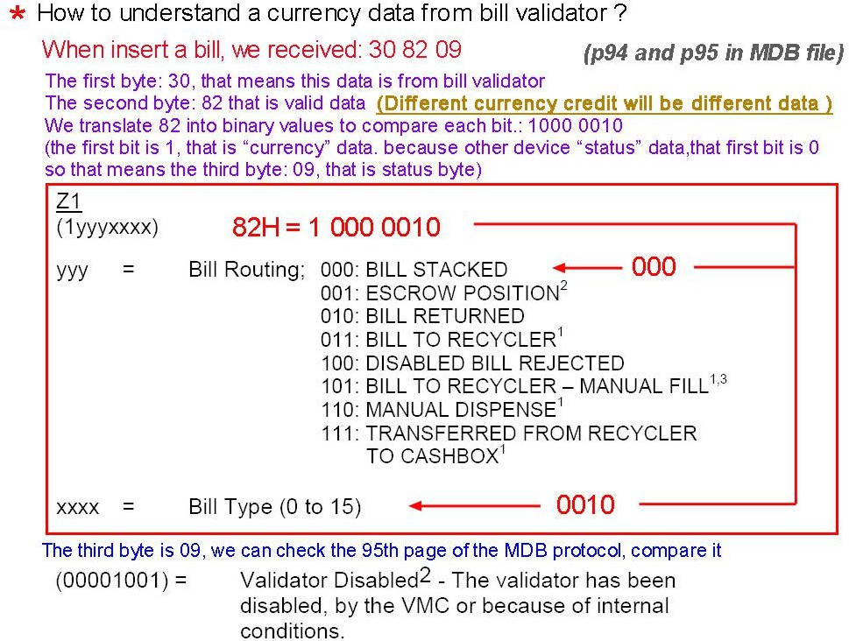
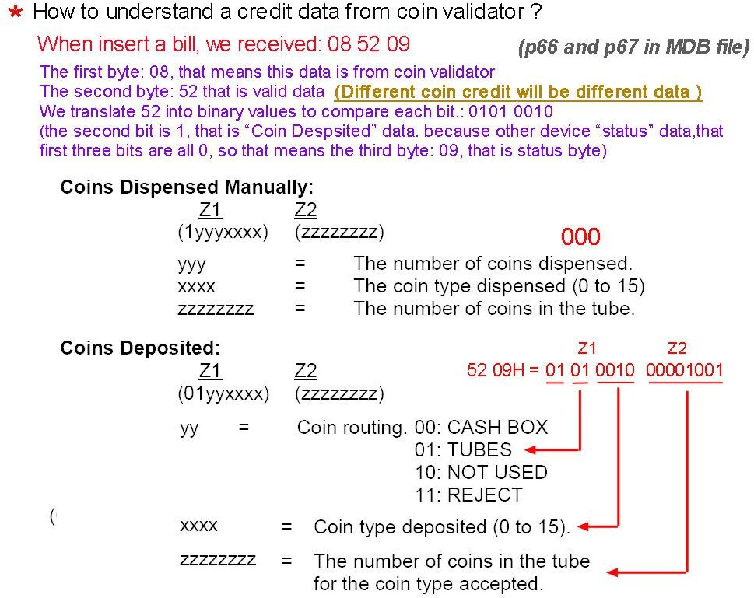

MDB-RS232 test with Nayax MDB cashless reader
Important note: if User want to test with Nayax card reader, must make sure that your card reader already connected to the nayax remote server system.that would be better to confirm with nayax servicer person. If not then MDB maybe cann’t test it.

MDB card reader has six working status:
- Inactive:
After powered on or after a Reset command,then device will go to this state.User can use the SETUP command to active the nayax reader
- Disable:
When card reader received the config data,will go to this "Disable" Status,Also If user send the "Disable" Command,also will go to this state.
- Enable:
After the "Enable" command and Before detected a valid card,then stay in this state.
- Session Idle:
When read a valid card,will go to "Session Idle" state to wait the "Vend request"
- Vend request
When received the "Vend request" from the VMC,will go to vend status
- Vend
Command List:

1401 Enable card reader | 1400 Diable card reader
1402 Cancel card reader | 1300000A0001 REQUEST VEND
1301 VEND CANCEL | 13020001 VEND SUCCESS
130500640001 CASH SALE | 1304 SESSION COMPLETE
1500 REQUEST REVALUE | 1700 REQUEST ID
110001000000 Config the card reader | 1101FFFF0000 Setup the max and min price

Steps for Testing with the card reader:
VMC: 110001000000 Config the card reader READER: 010109720102070D94 card reader reply
VMC: 1101FFFF0000 Set the maximum and minimum price READER: no reply

READER:  VMC: READER: | 03FFFE  1300000A0001  00 | Reading a valid card and wait the Vend selection  VMC command to card reader after Vend selection
READER: | 05000A | Card reader send to VMC, confirm the good dispatch
VMC: | 13020001 | VMC tell the card reader,already dispatch the selected goods
READER: |  | no reply
VMC: | 1304 | end the section.
READER: | 07

Important questions during application:
- Sometimes when send the command to the mdb-rs232,but I cann’t get any reply. How can I know if the command has already been sent successfully to the payment device?
Answer: In MDB-RS232 box design,when PC send the command to it ,it will forward the command to payment device. But sometimes the payment device is busy,for example a bill is inserted and payment device cann’t reply the box in time. So PC cann’t get the reply.then just need to resend the command later. Of course,this is not a problem,because ALL the command from PC,that is not a realtime command.
- How can I know if the payment device is enabled or disabled ?
Answer: If the payment device is in disabled status, Bill acceptors will report the status to PC always once each POLL. It will report 30 09 or 30 03 09 to PC, And also for most coin acceptor,if need the status, user can read the status with 0F05 command.
So When the power is just turned on, the bill validator device will be in the “Disabled” state, and such a status report will be received. If we send the enable command 34FFFF0000, the bill validator will enter the “Enabled” state and PC will not receive such a status report.
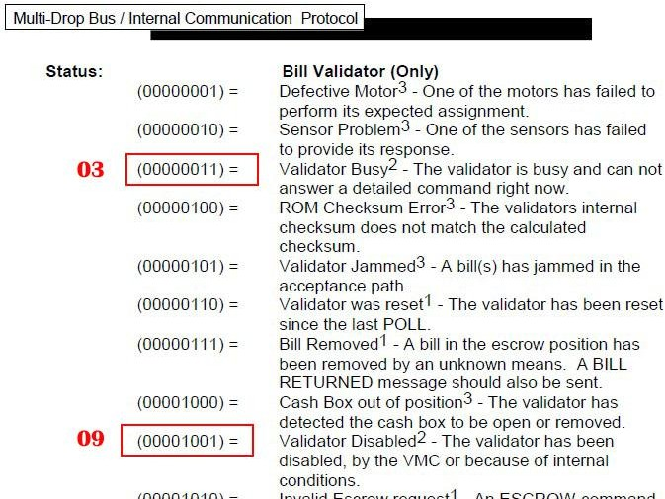
- If I can use a PLC or android board to connect it ?
Answer: That is no problem. Actually,user can use any main controller which has RS232 or USB port to work as the VMC.Of course, if the main controller only has the USB port.then will use a USB version. And install the USB Chip FT232RL driver to create the virtual com port in the main controller.
- If can supply more documents to facilitate the development of applications?

Answer: The MDB box we provide is to forward the data uploaded to the PC by the MDB payment device. The documents we provide can only make it as easy as possible for customers to understand the process of sending and receiving data and the structure of the data. As for the commands of the host, the design of the user's host software requires the user to design the control process after having a detailed understanding of the payment device and the MDB protocol. We are not able to provide assistance in customer specific projects and software design.
- About the Status reading command of coin acceptor (0F05 command to read the status)
Not all coin validators can report the full working status,especially the old version,even in Level03,also cann’t provide the proper status report data
Normally after powered on, it should report 01 00 06 00 07 (01/00 means powering up) Read the status again should report 06 00 06 (coin validator is disabled by default)
After use the command 0CFFFFFFFF to enable,then read status should report with 03 00 03 Must be noted: Some coin validators always report with 030003,no matter in what status and some only port with 000000. In these cases where the MDB protocol is not followed, please consult the coin validator manufacturer. Not a problem that MDB-RS232 boxes can solve
- How to use the 0F02 command to payout the coins Following is the samples to payout the coins:
Firstly from the setup command 09 to read the configuration data
03 11 56 05 01 00 03 01 02 00 00 00 00 00 00 00 00 00 00 00 00 00 00 76
From this configuration data, then two type coins, coin value is 0.5$ and 1$
Then use the 0A to check the tube status, which type and how many pieces in the tube For example: 00 00 03 01 00 00 00 00 00 00 00 00 00 00 00 00 00 00 04
then have two type of the coins and 03pcs 0.5$ and 1pcs 1$
So while the program is running, it must constantly check the status of the TUBE, so that it can know in real time how many coins can be paid out.
Then you can use the payout command 0F 02 01 to payout one pcs 0.5$ coin.
0F 02 02 to payout one pcs 1$ coin or 2pcs 0.5$ coin
That means you must have the coins in the tube and also that can be read by the 0A command,then can be payed out.

- What is the difference between normal MDB-RS232 and the 2020 Version MDB-RS232? Normal MDB-RS232 will send the enable command to the connected MDB coin acceptor, bill acceptor and the cashless device, but the 2020 Version MDB-RS232 will not do the job, just start to poll the slave payment devices and VMC will need to send these commands. So if we connect the coin and bill acceptors to MDB box and powered on, Even PC is not connected, Normal MDB-RS232 will enable the coin acceptor and bill acceptor and is ready to accept the coin or bills. But V2020 Version box, after powered on, all payment devices are in the disable status.

- If user can send the poll command from the PC ?
At present, our design is to complete the POLL command by the MDB-RS232 box. The POLL command cannot be sent from the PC. The PC only needs to process the remaining commands

and receive the corresponding data.

- How to use MDB-RS232® to test Bill recycler ?
We have a special file for bill recycler http://www.waferlife.com/downloads/How to use MDB Bill validator recycler.pdf

- Can the MDB-RS232 adapter support the age verification device interface? ?
Due to legal restrictions, a variety of products are only allowed to be vended via vending machines by checking the customers age. The age and the rules vary from country to country. This is i.e. related in some countries to cigarettes or alcoholic products. Some services or product contents may restrict a different age, related to the vending machine, this needs different ages to be checked within the same machine.
We also provide a specific MDB-RS232 box that can support age verification interface. But not all boxes support it by default. Need to consult when ordering.

How to order a sample to test ?
Answer : We can order the samples from online shopping store: http://cnkiosk.aliexpress.com

Wafer manufacture a series of the MDB payment adapters for Vending machines cashless payment system,wireless payment payment and Provide a rich solution for vending machine,kiosk machine or other self-service projects.

How can we connect the Pulse type coin acceptors or bill acceptors to PC ?
Answer: WAFER also have the PULSE-PC adapter box,that is used to connect the pulse type payment device to computer RS232 port.
We also can order the samples from: http://cnkiosk.aliexpress.com

How can we develop a cashless payment interface to existing vending machine?
Answer: WAFER also have the RS232-MDB adapter box,that is used to connect the RS232 interface PC or android main board or popular Raspberry pi board to vending machine,and then developer can use some simple command to act as a perfect cashless payment solution.
We also can order the samples from: http://cnkiosk.aliexpress.com

How can we develop a mobile payment solution for existing vending machine ?
Answer: WAFER have the 3G or 4G or LAN version payment module for selection. We also can order the samples from: http://cnkiosk.aliexpress.com

Where can we get more further information and get the fast technical service ?
http://www.waferlife.com/en/MDB2PC-PC2MDB.html

How to have a customized MDB or vending payment board ?
Answer : WAFER can provide users with customized control boards in the field of self-service vending. Including time control boards, payment interface boards, coin refunders, lottery machines and other control boards.

Both pre-sales and after-sales can receive help and advice through our online skype technical support.

Email: wafer@waferstar.com Web: http://www.waferlife.com Tel: 0086-21-51870528

Online Service Skype: wafer-service

V2021-V9.2
Copyright waferstar

